**Practical no 1:**

**Procedure:-**

**Code:-** <%@ Page Language="VB" AutoEventWireup="false" CodeFile="Register User.aspx.vb" Inherits="Register_User" %>

<!DOCTYPE html>

<html xmlns="http://www.w3.org/1999/xhtml">

<head runat="server">

<title></title>

<style type="text/css">

.auto-style1 {

width: 100%;

}

.auto-style2 {

text-align: right;

}

.auto-style5 {

width: 198px;

}

.auto-style6 {

width: 306px;

text-align: right;

height: 23px;

}

.auto-style7 {

width: 198px;

height: 23px;

}

.auto-style8 {

height: 23px;

text-align: center;

}

.auto-style9 {

width: 306px;

text-align: right;

height: 26px;

}

.auto-style10 {

width: 198px;

height: 26px;

text-align: center;

}

.auto-style11 {

height: 26px;

text-align: center;

}

.auto-style12 {

text-align: left;

height: 23px;

}

.auto-style13 {

text-align: center;

height: 26px;

}

.auto-style14 {

text-align: left;

height: 23px;

font-size: larger;

font-weight: 700;

}

.auto-style15 {

text-align: center;

}

.auto-style16 {

text-align: right;

height: 26px;

}

</style>

</head>

<body>

<form id="form1" runat="server">

<div>

<table border="0" class="auto-style1" contenteditable="inherit">

<tr>

<td class="auto-style14" colspan="3">Register User</td>

</tr>

<tr>

<td class="auto-style12" colspan="3">

<hr />

</td>

</tr>

<tr>

<td class="auto-style12" colspan="3">You must specify atleast one contact number</td>

</tr>

<tr>

<td class="auto-style2">Name :</td>

<td class="auto-style5">

<asp:TextBox ID="boxname" runat="server" Width="200px"></asp:TextBox>

</td>

<td class="auto-style15">

<asp:RequiredFieldValidator ID="RequiredFieldValidator6" runat="server" ControlToValidate="boxname" ErrorMessage="Choose Name "></asp:RequiredFieldValidator>

</td>

</tr>

<tr>

<td class="auto-style2">User Id :</td>

<td class="auto-style5">

<asp:TextBox ID="boxuid" runat="server" Width="200px"></asp:TextBox>

</td>

<td class="auto-style15">

<asp:RequiredFieldValidator ID="RequiredFieldValidator1" runat="server" ControlToValidate="boxuid" ErrorMessage="Choose User ID"></asp:RequiredFieldValidator>

</td>

</tr>

<tr>

<td class="auto-style16">Password :</td>

<td class="auto-style10">

<asp:TextBox ID="boxpass" runat="server" Width="200px"></asp:TextBox>

</td>

<td class="auto-style11">

<asp:RequiredFieldValidator ID="RequiredFieldValidator2" runat="server" ControlToValidate="boxpass" ErrorMessage="Choose Password"></asp:RequiredFieldValidator>

</td>

</tr>

<tr>

<td class="auto-style2">Confrim Password : </td>

<td class="auto-style5">

<asp:TextBox ID="boxcpass" runat="server" Width="200px"></asp:TextBox>

</td>

<td class="auto-style15">&nbsp;</td>

</tr>

<tr>

<td class="auto-style2">Gender :</td>

<td class="auto-style5">

<asp:RadioButtonList ID="RadioButtonList1" runat="server">

<asp:ListItem>Male</asp:ListItem>

<asp:ListItem>Female</asp:ListItem>

</asp:RadioButtonList>

</td>

<td class="auto-style15">

<asp:RequiredFieldValidator ID="RequiredFieldValidator3" runat="server" ControlToValidate="RadioButtonList1" ErrorMessage="Select Gender"></asp:RequiredFieldValidator>

</td>

</tr>

<tr>

<td class="auto-style6">Date Of Birth : </td>

<td class="auto-style7">

<asp:TextBox ID="boxdob" runat="server" Width="200px"></asp:TextBox>

</td>

<td class="auto-style8">

<asp:RequiredFieldValidator ID="RequiredFieldValidator4" runat="server" ControlToValidate="boxdob" ErrorMessage="Enter Date Of Birth"></asp:RequiredFieldValidator>

</td>

</tr>

<tr>

<td class="auto-style2">&nbsp;</td>

<td class="auto-style5">(dd/MM/yyyy)</td>

<td class="auto-style15">&nbsp;</td>

</tr>

<tr>

<td class="auto-style2">Country :</td>

<td class="auto-style5">

<asp:DropDownList ID="DropDownList1" runat="server" Width="200px">

<asp:ListItem>Select</asp:ListItem>

</asp:DropDownList>

</td>

<td class="auto-style15">&nbsp;</td>

</tr>

<tr>

<td class="auto-style2">Industry :</td>

<td class="auto-style5">

<asp:ListBox ID="ListBox1" runat="server" Width="200px">

<asp:ListItem>Education</asp:ListItem>

<asp:ListItem>IT</asp:ListItem>

<asp:ListItem>Software</asp:ListItem>

<asp:ListItem>Call Centre</asp:ListItem>

<asp:ListItem>Hardware</asp:ListItem>

</asp:ListBox>

</td>

<td class="auto-style15">

<asp:RequiredFieldValidator ID="RequiredFieldValidator5" runat="server" ControlToValidate="ListBox1" ErrorMessage="Select Industry"></asp:RequiredFieldValidator>

</td>

</tr>

<tr>

<td class="auto-style9">Telephone :</td>

<td class="auto-style10">

<asp:TextBox ID="boxtel" runat="server" Width="200px"></asp:TextBox>

</td>

<td class="auto-style11"></td>

</tr>

<tr>

<td class="auto-style2">Mobile :</td>

<td class="auto-style5">

<asp:TextBox ID="boxmob" runat="server" Width="200px"></asp:TextBox>

</td>

<td class="auto-style15">&nbsp;</td>

</tr>

<tr>

<td class="auto-style16">Email ID :</td>

<td class="auto-style10">

<asp:TextBox ID="boxemail" runat="server" Width="200px"></asp:TextBox>

</td>

<td class="auto-style11"></td>

</tr>

<tr>

<td class="auto-style11"></td>

<td class="auto-style10">

<asp:CheckBox ID="CheckBox1" runat="server" Text="I Agree Terms &amp; Condition" />

</td>

<td class="auto-style11"></td>

</tr>

<tr>

<td class="auto-style11" colspan="3"></td>

</tr>

<tr>

<td class="auto-style11"></td>

<td class="auto-style10">

<asp:Button ID="Button1" runat="server" Text="Submit" />

</td>

<td class="auto-style11"></td>

</tr>

<tr>

<td class="auto-style13" colspan="3">&nbsp;</td>

</tr>

</table>

</div>

</form>

</body>

</html>

**Output : -Designing Part**

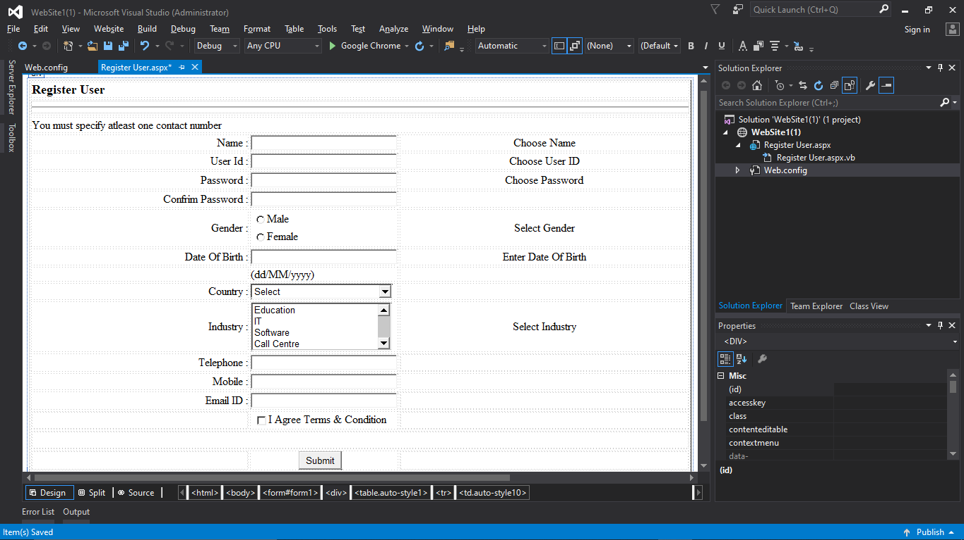

**1st utput:**

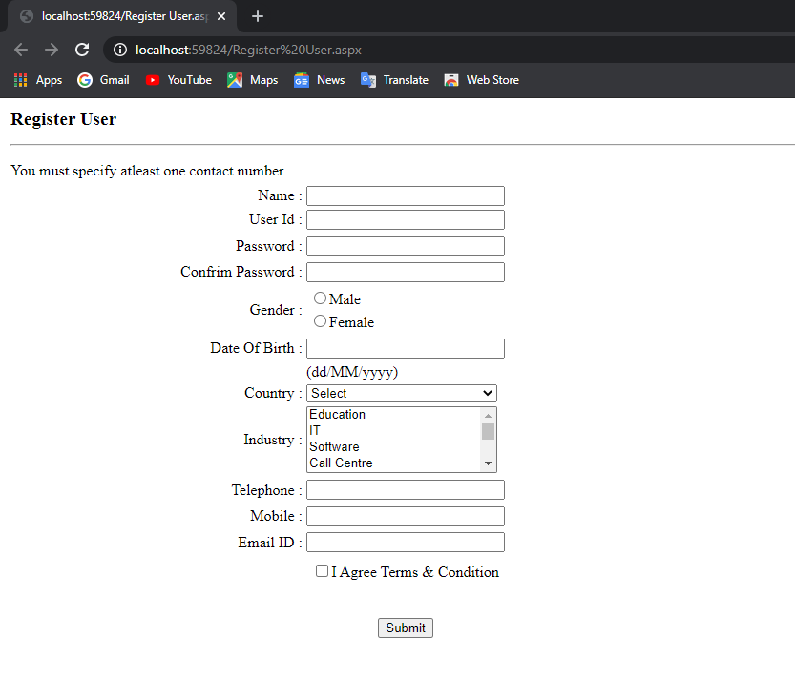

**2nd output :-**

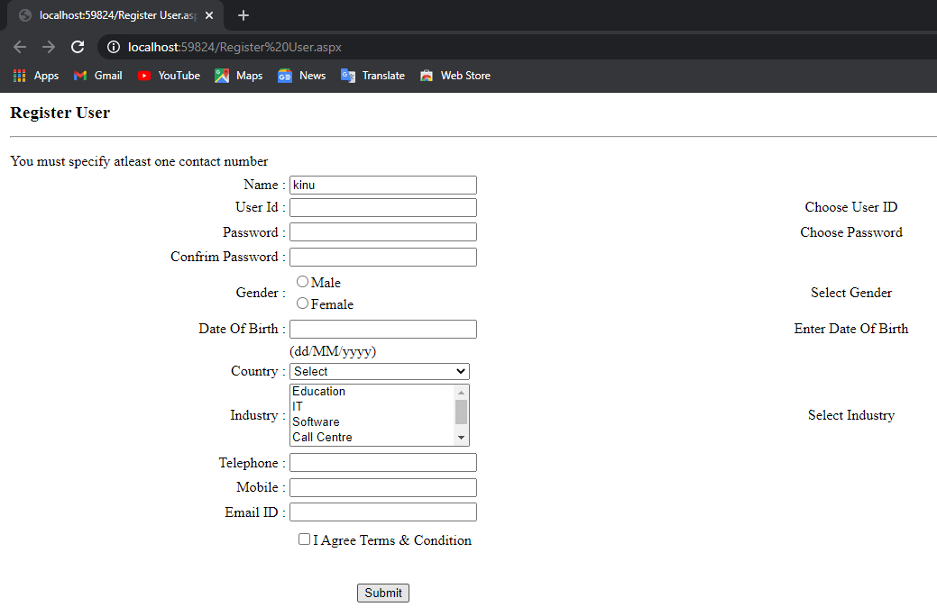

**Practical no 2:**

**Procedure:-**

using System;

using System.Collections.Generic;

using System.ComponentModel;

using System.Data;

using System.Drawing;

using System.Linq;

using System.Text;

using System.Threading.Tasks;

using System.Windows.Forms;

namespace practical_no_2

{

public partial class Form1 : Form

{

Double resultValue = 0;

String operationPerformed = " ";

bool isOperationPerformed = false;

public Form1()

{

InitializeComponent();

}

private void button_click(object sender, EventArgs e)

{

if ((textBox_Result.Text == "0")||(isOperationPerformed))

textBox_Result.Clear();

isOperationPerformed = false;

Button button = (Button)sender;

if (button.Text == ".")

{

if(!textBox_Result.Text.Contains("."))

textBox_Result.Text = textBox_Result.Text + button.Text;

}else

textBox_Result.Text = textBox_Result.Text + button.Text;

}

private void operator_click(object sender, EventArgs e)

{

Button button = (Button)sender;

if (resultValue != 0)

{

button20.PerformClick();

operationPerformed = button.Text;

labelCurrentOperation.Text = resultValue + "" + operationPerformed;

isOperationPerformed = true;

}

else

{

operationPerformed = button.Text;

resultValue = Double.Parse(textBox_Result.Text);

labelCurrentOperation.Text = resultValue + " " + operationPerformed;

isOperationPerformed = true;

}

}

private void button5_Click(object sender, EventArgs e)

{

textBox_Result.Text = "0";

}

private void button10_Click(object sender, EventArgs e)

{

textBox_Result.Text = "0";

resultValue = 0;

}

private void button20_Click(object sender, EventArgs e)

{

switch(operationPerformed)

{

case "+":

{

textBox_Result.Text = (resultValue + Double.Parse(textBox_Result.Text)).ToString();

break;

}

case "-":

{

textBox_Result.Text = (resultValue - Double.Parse(textBox_Result.Text)).ToString();

break;

}

case "*":

{

textBox_Result.Text = (resultValue * Double.Parse(textBox_Result.Text)).ToString();

break;

}

case "/":

{

textBox_Result.Text = (resultValue / Double.Parse(textBox_Result.Text)).ToString();

break;

}

default:

break;

}

resultValue = Double.Parse(textBox_Result.Text);

labelCurrentOperation.Text = "";

}

}

}

**Output: Designing Part :-** **1st output addition part:-** **addition ans:-**

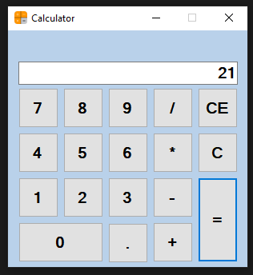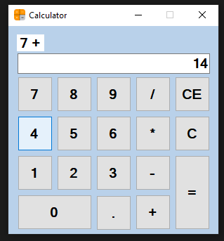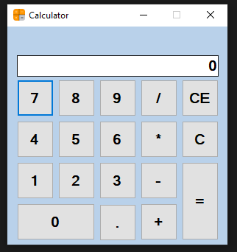

**2nd output:- Subtraction** **subtraction ans:-** **3rd output:- multiplication**

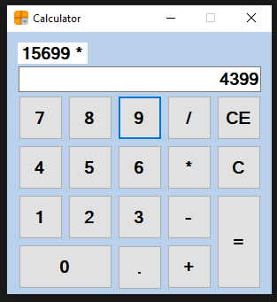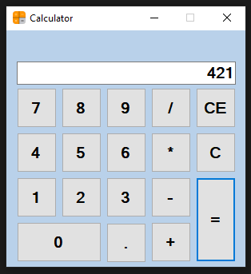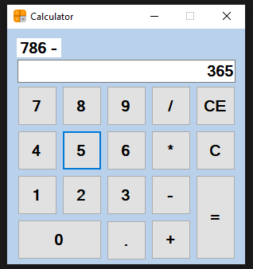

**Multiplication ans:-** **4th output:- division** **division ans:-**

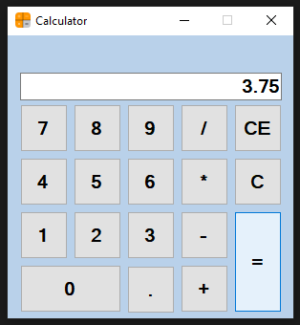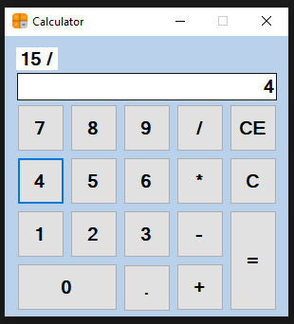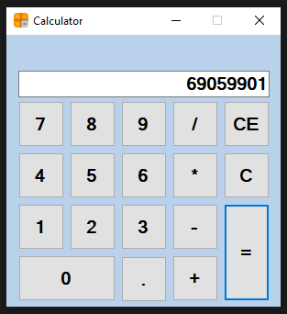

**5th output :- clear button**

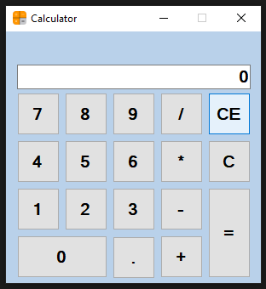

**Practical no 3:**

**Procedure :-** using System;

using System.Collections.Generic;

using System.Linq;

using System.Text;

using System.Threading.Tasks;

namespace Practical3

{

class Program

{

static void Main(string[] args)

{

int a, b;

Nullable<int> result= null;

Console.WriteLine("*****MENU*****");

Console.WriteLine("1)LAYS-5 Rs");

Console.WriteLine("2)COKE-20 Rs");

Console.WriteLine("3)WATER-30 Rs");

Console.WriteLine("4)CHOCOLATE-20 Rs");

Console.WriteLine("5)JUICE-25 Rs");

Console.WriteLine("Enter the amount:");

a = Convert.ToInt32(Console.ReadLine());

Console.WriteLine("Enter your choice:");

b = Convert.ToInt32(Console.ReadLine());

switch (b)

{

case 1: result = a - 5; break;

case 2: result = a - 20; break;

case 3: result = a - 30; break;

case 4: result = a - 20; break;

case 5: result = a - 25; break;

}

Console.WriteLine("Remaining Balance:" +result);

Console.ReadKey();

}

}

}

**Output:**

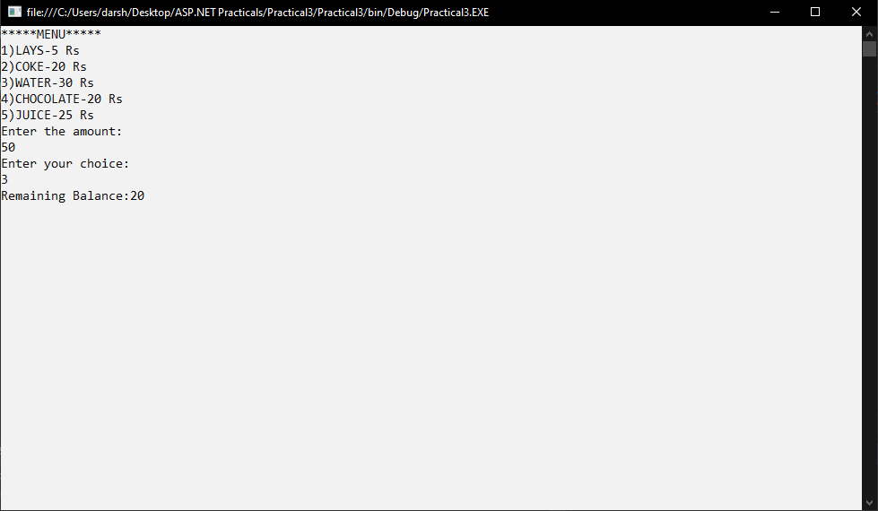

**Practical No.4:-**

**Procedure:-**

using System;

using System.Collections.Generic;

using System.Linq;

using System.Web;

using System.Web.UI;

using System.Web.UI.WebControls;

public partial class loginattempths : System.Web.UI.Page

{

protected void Page_Load(object sender, EventArgs e)

{

}

public static int num;

public void count()

{

num++;

}

protected void Button1_Click(object sender, EventArgs e)

{

if (num < 3)

{

if (TextBox1.Text == "Darshan" && TextBox2.Text == "pass")

{

Label1.Text = TextBox1.Text + " is successfully logged in !!!";

}

else

{

count();

Label1.Text = "Username and password is incorrect!!! "+(num)+" Attempts";

}

TextBox1.Text = "";

}

else

{

Label1.Text = "tired for too many time!!!";

TextBox1.Text = "";

TextBox1.Enabled = false;

TextBox2.Enabled = false;

}

}

}

**Output:- login page** **login successfully:-**

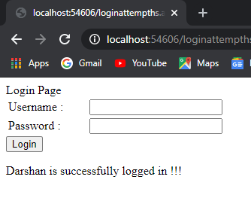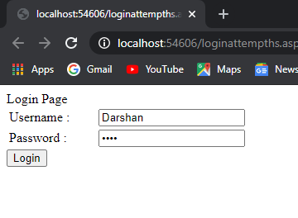

**incorrect user & pass:-** **1 Attempts:-**

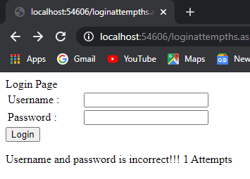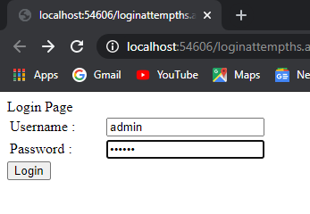

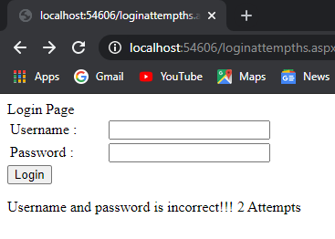**2 Attempts:-** **3 Attempts:-**

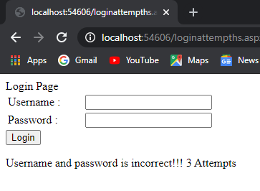

**Try again:-**

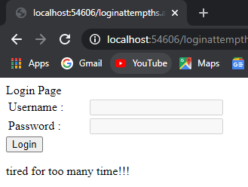

**Practical No.5:-**

**Procedure:-**

using System;

using System.Collections.Generic;

using System.Linq;

using System.Web;

using System.Web.UI;

using System.Web.UI.WebControls;

public partial class pn5 : System.Web.UI.Page

{

protected void Button1_Click(object sender, EventArgs e)

{

Label1.Text = "Total is" + Convert.ToInt32(TextBox1.Text) * Convert.ToInt32(TextBox2.Text);

}

protected void DropDownList1_SelectedIndexChanged(object sender, EventArgs e)

{

TextBox1.Text = DropDownList1.SelectedValue;

}

}

**Output:-**

